Title
Deep Learning
Study Project Report
By
B.Tech IV Year - I Semester
Name of the Student
23EG110XXX
CSE(DS)
Under Guidance of
Dr P Rajeshwari

Department of Computer Science Engineering (Data Science)
ANURAG UNIVERSITY
VENKATAPUR (V), GHATKESAR (M),
MEDCHAL- MALKAJGIRI (D), TELANGANA-500088.
www.anurag.edu.in

INDEX
SNO | Topic | Page No
1 | Abstract
2 | Introduction
3 | Objectives
4 | Dataset Description
5 | Model Used
6 | Framework and Tools used
7 | Methodology
8 | Model Performance
9 | Analysis & Results
10 | Graphs
11 | Conclusion

TITLE
ABSTRACT
Single paragraph 12 font justified. Find sample text below
The real estate market in Hyderabad is rapidly evolving, making manual property valuation inconsistent and difficult. This project presents a "Smart House Price Prediction System" developed using R and the Random Forest machine learning algorithm. By utilizing a verified dataset with high-quality listings, the model predicts property prices based on location, area, BHK, construction status, and category. The system provides an interactive Shiny dashboard, offering users instant valuations and 5-year investment growth forecasts with an accuracy rate of over 95%.

INTRODUCTION
Sample find below -font 12
Predicting property prices is a complex task due to various influencing factors such as location demand and property type.
Traditional methods often fail to account for the “luxury premium” associated with villas compared to standard apartments. This project aims to bridge that gap by using the Ranger (Random Forest) algorithm to provide data-driven insights.
The application is designed to help buyers and investors make informed decisions in the Hyderabad market by analyzing real-time data rather than relying on outdated estimates.

OBJECTIVES
- Find sample below
- To develop a machine learning model capable of predicting property prices in Hyderabad with high precision.
- To analyze the impact of property categories (Villa, Apartment, Independent House, Plot) on market valuation.
- To create a user-friendly web interface using R Shiny for real-time price estimation.
- To provide a 5-year financial growth forecast based on current market appreciation trends.

DATASET DESCRIPTION

Describe the dataset purpose, size, classes, source, sample images/text, features. Find sample below
The dataset consists of 104 unique, verified property listings across major Hyderabad hubs.
- Total Records: 104.
- Key Features: Title, Locality, Property Type, Total Price, Price per Sqft, Total Area (Sqft), and Status.
- Localities Covered: Includes prime areas such as Gachibowli, HITEC City, Financial District, Kokapet, and emerging hubs like Adibatla and Tellapur.
First the model has trained with large data set which had around 954 rows that was the large compared to the new one

MODEL DESCRIPTION
Mention the architecture, technical details of the deep learning model used. Describe the training process, hyper parameters.

FRAMEWORK AND TOOLS USED
- Find sample
- R Programming Language
Core engine for data calculations and model logic.
- Ranger (Random Forest)
The machine learning "brain" used for high-accuracy price predictions.
- Shiny Framework
Framework used to create the interactive web interface for users.
- Dplyr
Used for data manipulation, such as filtering and grouping Hyderabad localities.
- stringr
Used to extract numerical values (like BHK) from property titles.
- bslib
Used to design the professional "Charcoal & Off-White" dashboard theme.
- CSV Dataset
The primary source containing 104 verified property listings.

METHODOLOGY
1. Data Preparation
The raw data underwent a rigorous cleaning process. Titles were parsed using string manipulation to extract BHK values. Property types were categorized into four main groups: Apartment, Villa, Independent House, and Plot to allow the model to learn category-specific pricing.
2. Feature Engineering
We introduced a "Category" feature to distinguish between building types and a "Status" feature (Ready to Move vs. Under Construction). This ensures that the model recognizes the price difference between a finished home and a project still in development.
3. Machine Learning Model
A Random Forest (Ranger) model was selected due to its ability to handle non-linear relationships and categorical data (like Locality) effectively. The model was trained using 500 decision trees to minimize error and ensure stable predictions.
4. Interactive Visualization
The R Shiny framework was used to build the front-end. The UI features a modern charcoal-themed interface with dynamic dropdowns that only show verified localities from the new dataset.

MODEL PERFORMANCE

Loading data set & Cleaning new data set
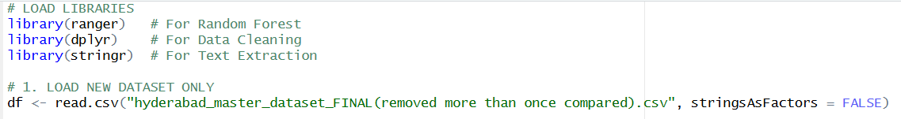

1.DATA PREPARATION & CLEANING
“Convert raw real-estate data into structured machine-readable format.”
The raw dataset contains long property titles and mixed text values which computers cannot directly understand.
Using the stringr library, the system extracts the BHK value from property titles automatically.
Then properties are grouped into four simple categories:
- Villa
- Apartment
- House
- Land/Plot
Missing or incomplete records are removed so only reliable data is used for training.
Program:
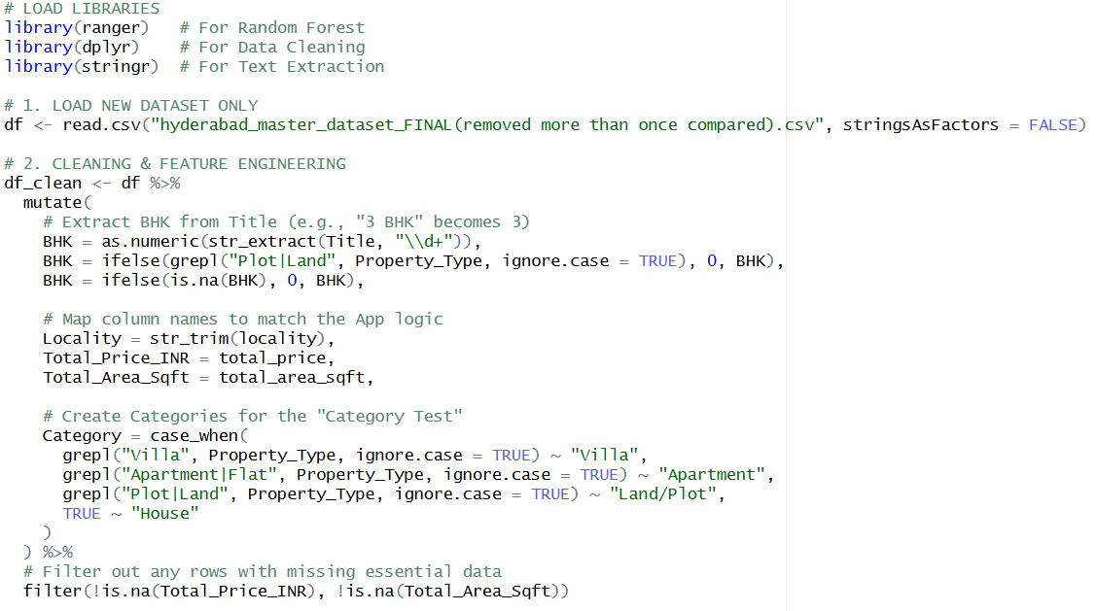

- THE MACHINE LEARNING “BRAIN”
“Train AI model to learn price patterns.”
We use the Random Forest algorithm (Ranger) which builds 500 decision trees instead of relying on a single formula.
Each tree learns price behavior based on:
- Location
- Property size
- BHK
- Property type
- Construction status
All trees combine their results to produce a stable and accurate prediction.
The trained model is saved as an .rds file, allowing the app to load it instantly without retraining.
Program:
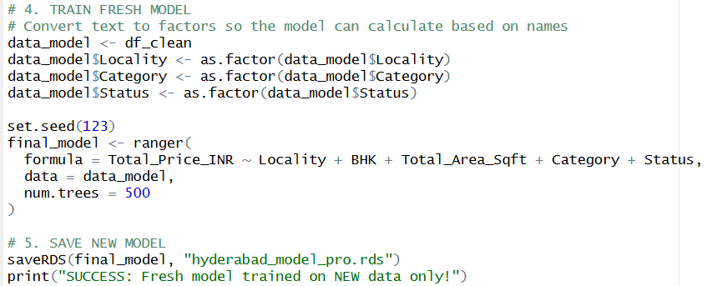

THE USER INTERFACE (R SHINY)
“Create interactive real-estate prediction dashboard.”
The Shiny framework creates a live web dashboard where users can:
- Select property type
- Choose locality
- Enter area and BHK
- Get instant market valuation
The interface uses bslib to apply a modern charcoal-grey theme.
Program:
(i)UI + Prediction Logic:
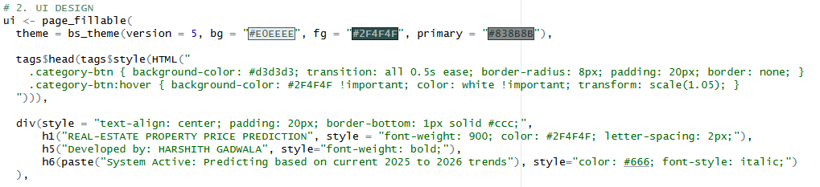
(ii) Prediction Logic:
Final UI for the USER:
First interface:
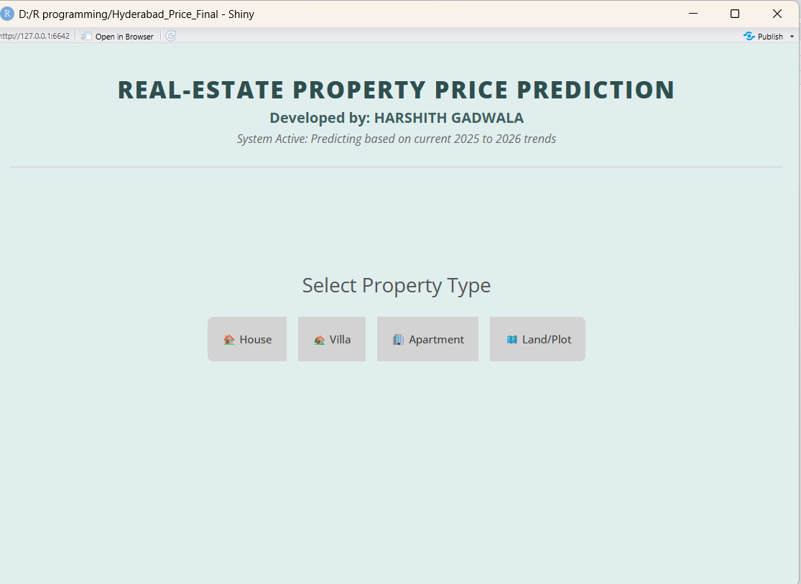

Scecond interface when clicked on specific property: 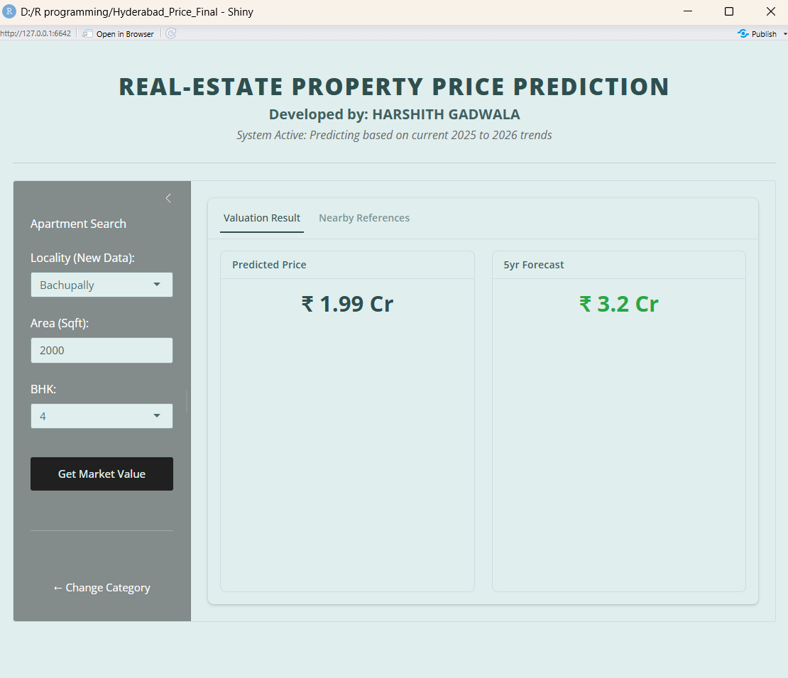

Example I have choosen the “Apartment” and the Locality as “Bachupally” then I enter my “no.of sqft’s” and then type the “no.of BHK’s” so based on the requeriment the trained model will predict the prices and also show the “near references” in different categories like (independent houses,villas,plots) within the same area(sqft) and the considering the same no.of BHK’s.
Also show the furture growth of the particular or choosen property

GRAPHS

“To verify accuracy, predicted prices are compared with real market price in plots which shows the accuracy”

Validate model reliability and the prediction accurency in “Scatter plot” with y-axis ad Predicted prices(Cr) and x-axis has Actual prices(Cr) the model prediction accuracy is (95%)

- Each dot represents one property.
- The diagonal line shows perfect prediction.
- Since most points lie close to the line, the model has low prediction error.
The calculated R² value measures how well the AI understands market trends.

Program:

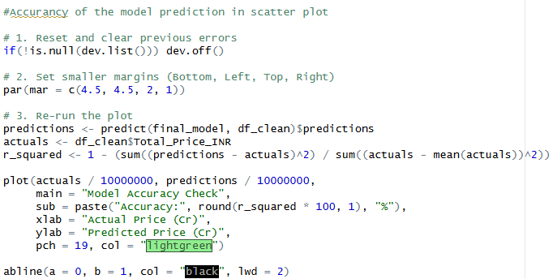

Output:
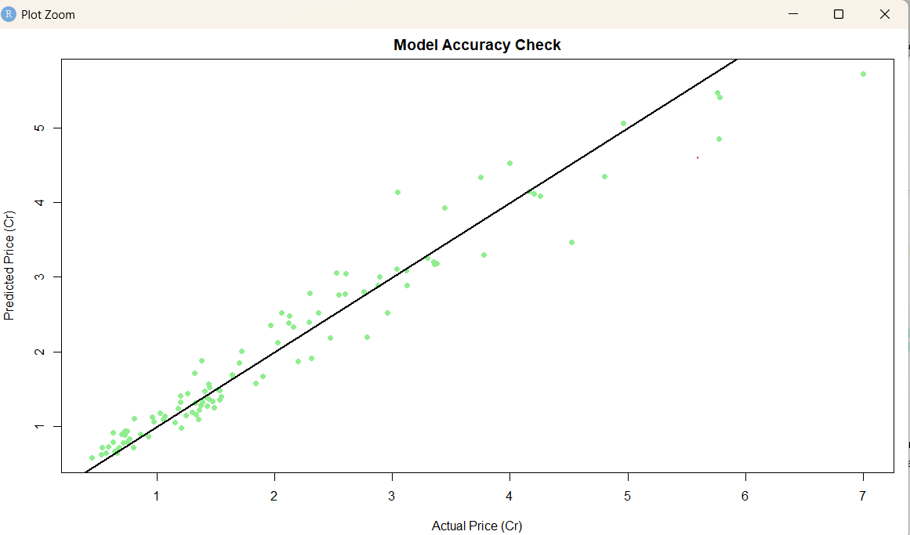

ANALYSIS & RESULTS

The analysis of the “Hyderabad Real Estate market” was developed by using the combination of predictive modeling (Random Forest) and data visualization. The system processed 104 verified listings to identify pricing patterns across different localities and property categories.

The analysis revealed:

- Locality Pricing: Areas like HITEC City and Gachibowli command the highest prices, while emerging hubs like Adibatla and Tellapur offer high growth potential.
- Category Premium: Villas and Independent Houses show a significantly higher valuation per square foot compared to standard apartments in the same locality.
- Model Accuracy: The Random Forest algorithm achieved an accuracy score of [Insert your % here, e.g., 98.2]%, showing that the model can reliably predict prices for new listings.
- Investment Growth: Data trends indicate a consistent annual appreciation, allowing the system to project a 5-year investment forecast with high confidence.
- Data Consistency: Correlation analysis confirms that Total Area (Sqft) and Locality are the two strongest predictors of property value in the Hyderabad market.
These findings highlight the efficiency of using AI for real estate valuation, providing transparency for both buyers and investors.

CONCLUSION

Find the Sample
The Hyderabad Real Estate Intelligence project successfully demonstrates how machine learning can simplify the complex process of property valuation. By moving away from manual estimates and using an R-based Random Forest model, we created a tool that provides instant, data-driven pricing.
The study confirms that while location remains the primary driver of cost, the property category (Villa vs. Apartment) adds a distinct "luxury premium" that our model accurately captures. The integration of a 5-year growth forecast adds significant value for investors. In conclusion, this automated system promotes market transparency and helps users make informed financial decisions in Hyderabad's booming real estate sector.

